Acceptable Boys Swim Wear Unacceptable Boys Swim Wear

[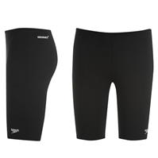](http://www.sportsdirect.com/speedo-end-jammer-swim-shorts-junior-351009?colcode=35100903)

[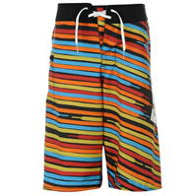](http://www.sportsdirect.com/dc-lace-stripe-board-shorts-junior-boys-350272?colcode=35027203)





[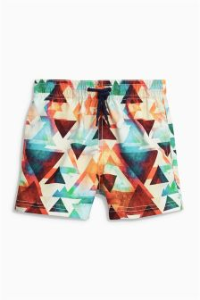](http://www.next.co.uk/gc11012s6#464157)

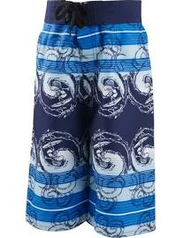

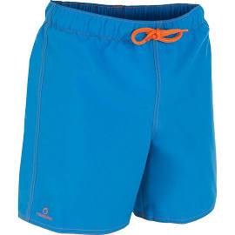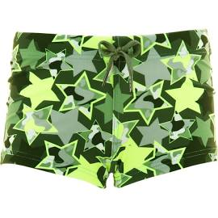[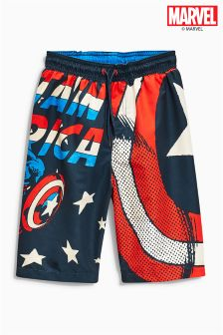](http://www.next.co.uk/gc1236s2#884963)[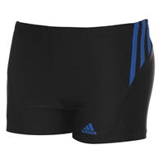](http://www.sportsdirect.com/adidas-sport-boxer-swim-shorts-junior-boys-351000?colcode=35100048)