REGISTERING FOR HOME PORTAL – PARENTS GUIDE

Parent’s are now able to view their child’s swimming progress online via our home portal.
To register, please enter the following link into your web browser:
https://learning4life.courseprogress.co.uk/register
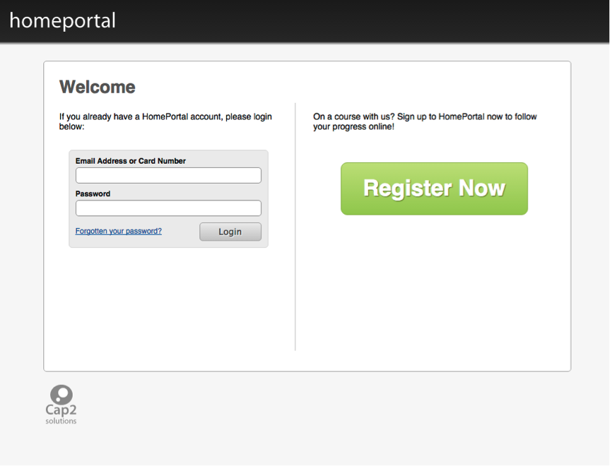
Click the Register Now button.

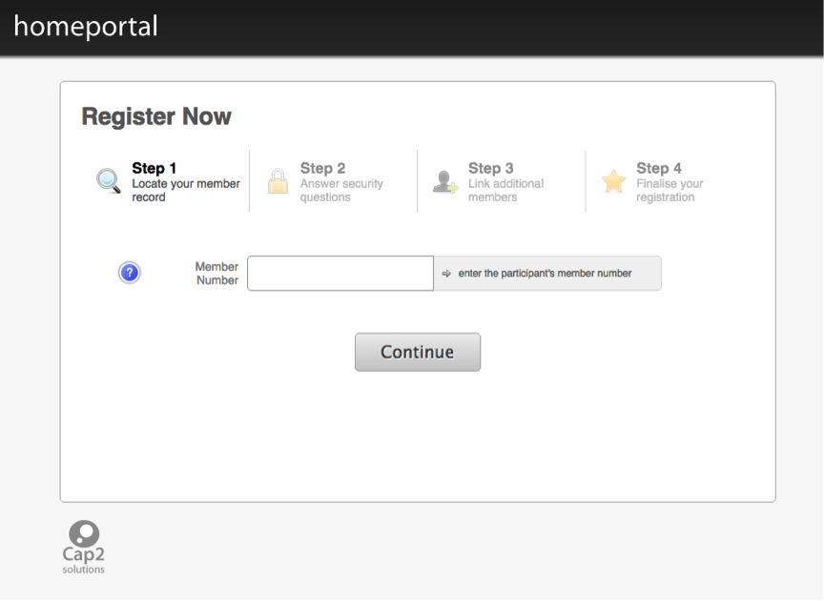
Step 1 - Locate your member record (this will be detailed on your enrolment email, the number start 1000 – swim school reception will be able to reconfirm this if required)
Your child must be a member of Swim School to register for Home Portal.
Enter your member record number for this.
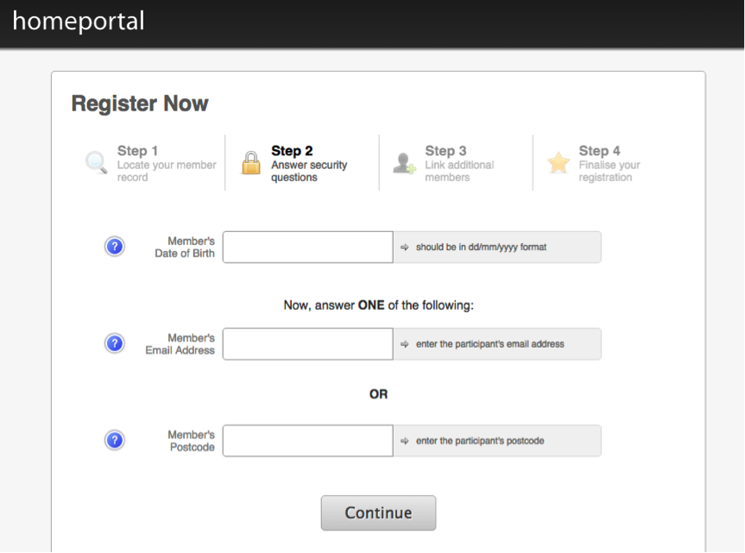
Step 2 - Answer security questions
Enter the date of birth of the member
AND
The Email Address given to the Swim School upon registration
OR
Postcode of the member
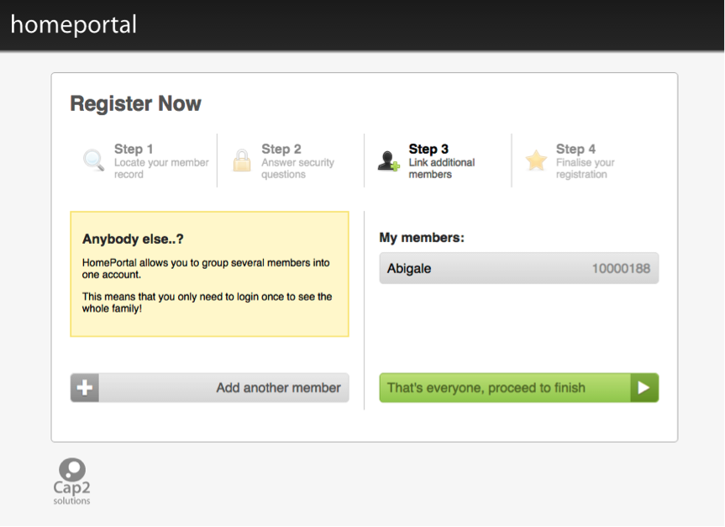
Step 3 - Link additional members
Allows you to link other members to your Home Portal account (e.g. other family members enrolled in Swim School).
Enter the date of birth of the member
AND
The Email Address given to the school upon registration
OR
Postcode of the member
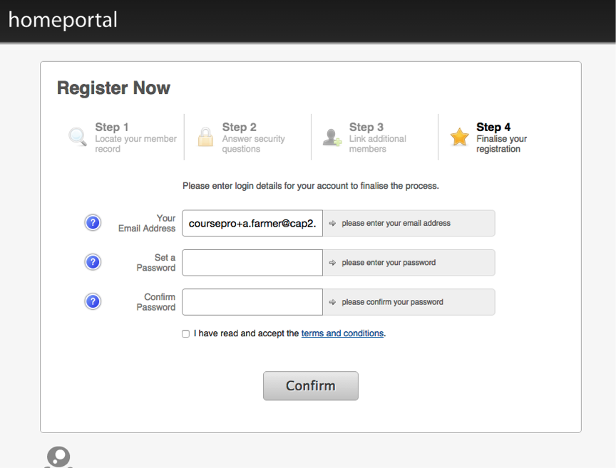
Step 4 - Finalise your registration
Insert a password
Confirm the password
Tick the "I have read the terms and conditions" check box. An email will be sent to you, you must click on the link within the email to activate your account.

